4:12- SS Leadership Meeting Agenda
April 12, 2026

Celebration
- Easter!
- Attendance- 550!
- Guests- 36 first-time guests gave us their information
- Invitation Contest Results
- 1 Quarter Attendance Numbers
Class | Enrollement | 2026 1st Q Av | 2025 1st Q Av | Growth
Students | 79 | 38 | 35 | 3
YA 1- Below/Smith | 33 | 10 | 10 | 0
YA 2- Sarnes | 51 | 21 | 16 | 5
HB- Mabe/Schlumbohm | 43 | 21 | 17 | 4
Median- Jennings/VanHoose | 58 | 18 | 19 | -1
Ladies- Bare | 47 | 15 | 12 | 3
JH- Gentry/Hendricks | 89 | 35 | 28 | 7
PT- Fawcett/Heck | 56 | 23 | 20 | 3
Seniors- August | 42 | 22 | 17 | 5
Total | 498 | 203 | 174 | 29

Today’s Topic: Sunday School Assimilation! (Make hay while the sun shines)

As Sunday School class leaders, we can use this spring and summertime to grow our classes through assimilation. We can do this by taking 4 actions.

Thinking “assimilation” through Relationships.
  - Assimilation Defined- the intentional process of moving guests from attendance to active, long-term membership by fostering connections. Assimilation is the process by which a part becomes a part of the whole.
  - Why is assimilation important?
    - Someone becoming a part of the group facilitates all the ministry that needs to happen in their life from the church.
      - Salvation
      - Baptism
      - Discipleship
      - Church attendance
      - Bible Reading
      - Prayer
      - Ministry
      - Evangelsim
  - What does assimilation have to do with relationships?
    - With people, this means assimilation is all about relationships.
    - Ministry best takes place across the bridge called relationships.
    - Growing in a relationship to others in the church becomes the basis for ministry.
  - What does Sunday School have to do with assimilation?

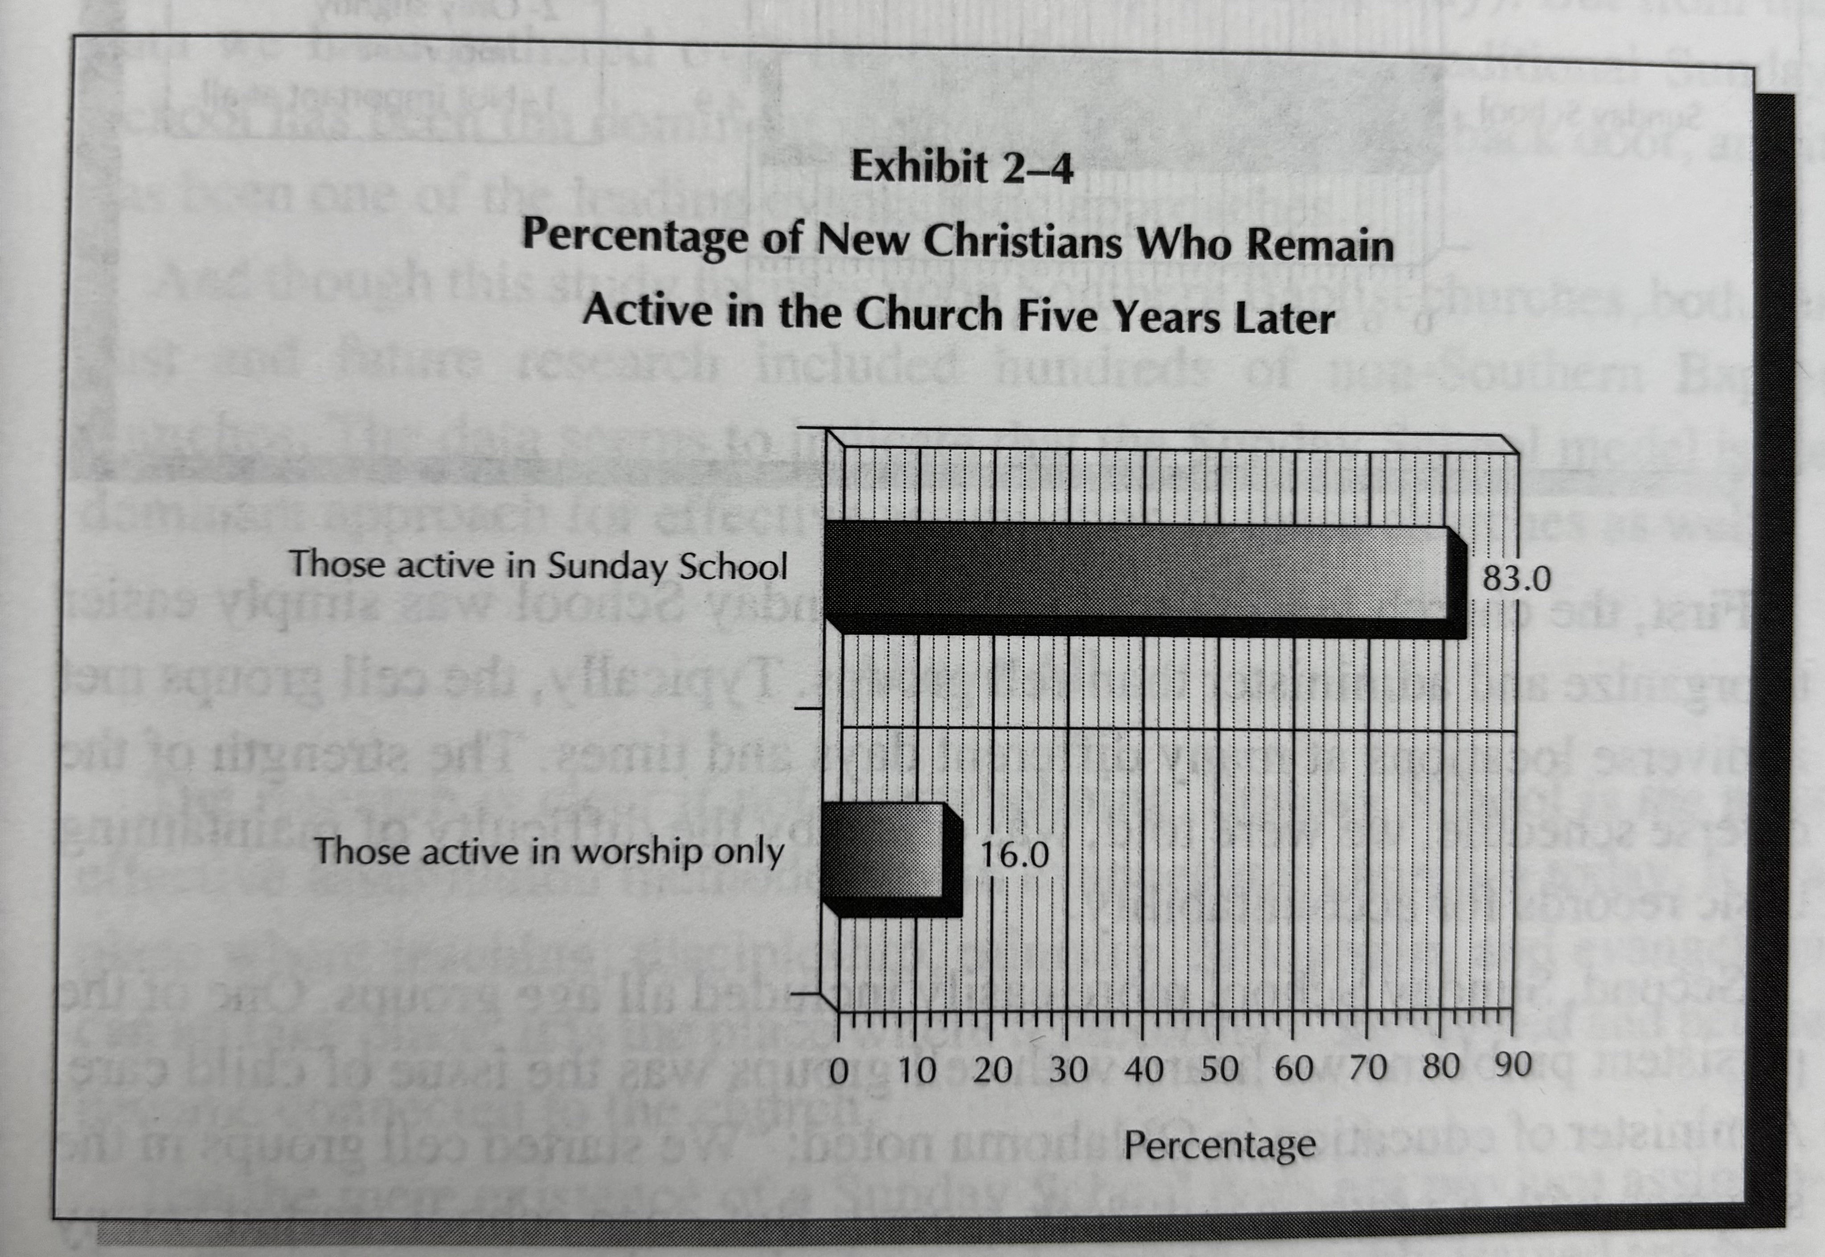

Based on research done by Thom Ranier (High Expectations by Thom Ranier page 45)

Making class time aimed at assimilation.
  - Arriving early.
  - Being proactive at greeting.
  - Being proactive at connecting.
  - Showing care through prayer requests (in class and out of class).
  - Emergency! Someone walked in and no one is talking to them.
  - Teaching the lesson to the people you have.

Planning Activities that start and build relationships.
2 Questions to ask:
- Who are you trying to reach or assimilate?
- What are the best practices for activities that assimilate?
  - Use activities as an excuse for contacting and inviting.
  - Make sure they are good.
  - Make sure they match your people.
  - Let us help you. (Communication, Invitations, Activity Request Form)
  - Planning Template

Recruiting leaders to facilitate relationships
- A task- Recruit activity help
- A role- Care Group Leaders

Application

Here are 7 discussion questions to apply this with your team:
- Defining the Win — How would you describe the difference between someone attending your class and someone being truly assimilated into it? What does that look like practically in your specific class?
- The Ministry Bridge — The content says "ministry best takes place across the bridge called relationships." Can you think of a time when a deeper relationship with a class member opened the door to a significant ministry moment in their life?
- Early Arrival Culture — What would it take for your class to develop a culture where members consistently arrive early and proactively greet guests — rather than that falling entirely on the teacher?
- The Emergency Scenario — Someone walks in and no one is talking to them. What is your current plan for that moment? Who in your class could you designate as a "first contact" person?
- Activity Planning — What is one activity — big or small — you could plan this spring or summer that would naturally build relationships and give you a reason to contact and invite people who are on the fringe of your class?
- Matching Activities to Your People — The content emphasizes making sure activities "match your people." What does your class demographic look like, and what kinds of activities are most likely to actually get them to show up and connect?
- Multiplying the Effort — You can't build every relationship yourself. Who in your class has the gift or personality to serve as a Care Group Leader or relationship facilitator — and what would it look like to recruit and develop them for that role?

